Herewith detail of quotation and itinerary for reference group: Rates 2020

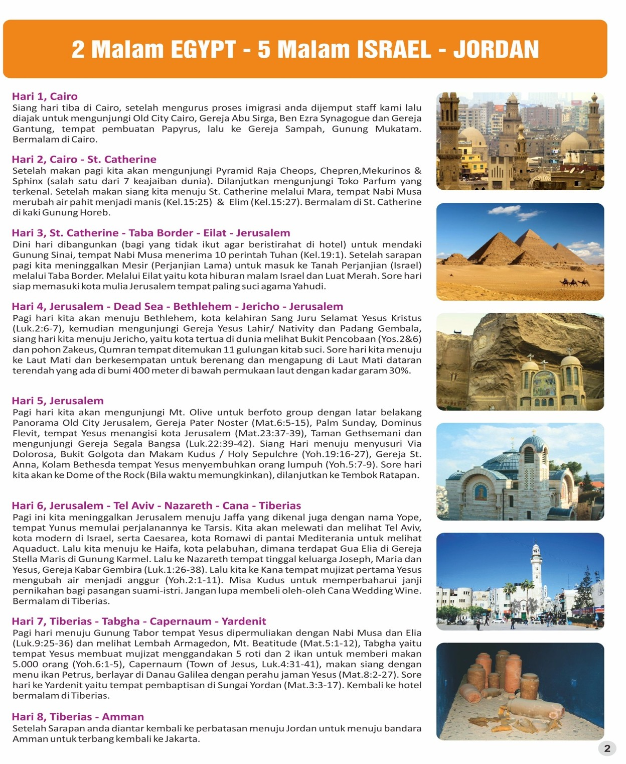

Rates per person on half double/triple occupancy Not valid in Jewish and Christian Holidays

|  |  |  |  |  |  |  |  |
| --- | --- | --- | --- | --- | --- | --- | --- |
| 45+3.5 | 40+3.5 | 35+2.5 | 30+2.5 | 25+1.5 | 20+1.5 | 15+1.5 | s/s |
| $ 607 | $ 612 | $ 635 | $ 657 | $ 678 | $ 720 | $ 780 | $ 185 |

|  |  |  |  |  |  |  |  |
| --- | --- | --- | --- | --- | --- | --- | --- |
| 45+2 | 40+2 | 35+2 | 30+2 | 25+2 | 20+2 | 15+2 | s/s |
| $ 593 | $ 605 | $ 727 | $ 648 | $ 690 | $ 733 | $ 797 | $ 185 |

Prices included

* Pick up Cairo Airport and end of services Amman Airport
* 1 Night Cairo: Intercontinental
* 1 Night Dahab or St Catherine: Le Meridien or Morgen land
* 3 Lunches and 3 dinners in Egypt
* 3 Nights Bethlehem: Oriental Palace or similar
* 2 Night Nazareth: Nazareth Plaza or Bali or Club
* 4 Lunches and 5 dinner in Israel
* 1 Lunch in Jordan
* Wifi A/C Bus with professional licensed Indonesian speak guide based on availability

On arrival, hat and map of Holy land, Pilgrims certificate,2 mineral water per day,

* 1 Magnetic picture per person
* Regular entrances Main churches, Boat ride Tiberias, Mt Tabor, Garden Tomb, Aqueduct in Caesarea, Qumran, Mt Nebo, Pyramids and Sphinx

Prices excluded:

* Visa Egypt us 25 pp
* Sinai Tax us 5 pp
* Visa Israel: Us 12 pp
* Sheik Hussein Border us 30 pp
* Visa Jordan: us 58 pp
* Tips to guide, driver, restaurants, and porters. Personal items and extra beverages on meals
* Cable Jericho, Caesarea park, Masada, Nazareth Village Mt Hermon**,** Western Tunnel

# Payments and Deposit

* frees of charge (foc) are based on half twin (In case stay in single, the supplement single will apply by the hotels)
* 2 Children in same rooms without parents or 1 adult and 1 child is same room will be charge as per 1 double
* If any member of the group cancels, we will charge the group as per the new number of participants
* In case of not full payment invoice before departure, all services will be cancelling, and full cancelation fees will be charged

# VISA ISRAEL APPLICATION

* Visa need to be applied 35 days before arrival in Israel
* (When the visa is applying, we cannot update any modification, so be careful when you file all details) Children under 18 years need to be accompanied by mother or father
* Need scanner passport for apply visa in Egypt
* Need pnr 1 week before arrival in Egypt for apply ok on border